What to pack

Here’s a list of things you’ll need to pack – along with a few that aren’t essential but could be useful.

Things you need:

- Luggage – please restrict this to one case plus one piece of hand luggage.
(Metal frames rucksacks should be avoided as they are difficult to fit into the coach)
- Sleeping bag & Pillowcase
- A drink bottle (essential in the summer)
- Torch (for evening walk)
- Rucksack
- Toiletries etc (please note deodorants must be roll-on, no aerosols)
- Old clothes for activity sessions – (long-sleeved shirts/jumpers, trousers / jogging bottoms (Not denim jeans), T-Shirts and closed-toe shoes are required for nearly all sessions so bring plenty). Clothes, shoes and underwear for other times.
- Waterproof clothing (jacket / trousers)
- Large plastic bag for dirty clothes
- Bath towels x 2
- Hat & Gloves in the winter
- Sunglasses, sun cream and hat in the summer
- Pyjamas and slippers
- Swimming kit - if you have swimming on your programme (this applies for Culmington Manor only)
- Sleeping Bag/pillow case

Useful items:

- Books, playing cards and other quiet activities
- Money for snacks (sweets & drinks) , souvenirs (i.e postcards). Please bring coins not notes.

Useful notes:
- No wellies
- Please name all clothing
- Denim jeans are not ideal for outdoor use

Manor Adventure can’t accept liability for the loss of any personal property brought to our centres – so please don’t bring any valuable items, expensive clothing and footwear, mobile phone, handheld games consoles etc. We’re unable to store them and they won’t be insured whilst on centre.

Page 12

WHAT TO WEAR ON SESSIONS

OBSTACLE COURSE AND BLIND TRAIL
Wear old clothes and safe shoes/trainers. Wear long trousers and long sleeves

DO NOT WEAR SHORTS (You will get muddy on these sessions, possibly wet as well).

ARCHERY Make sure you are wearing a long sleeved top.

CANOEING AND RAFT BUILD (Depending on the time of year)
Wear 1or 2 layers of warm clothes for example:
T-shirt, long sleeved top and jogging bottoms.
Wear waterproof jacket and trousers.
Wear old footwear, for example: trainers, pumps/gym shoes.

DO NOT WEAR JEANS. DO NOT WEAR WELLINGTON BOOTS.

Bring a towel in a plastic bag and a complete change of clothes, for example:
T-shirt, long sleeved top and jogging bottoms.

If you are taking medication please remember to bring it with you.

HILLWALKING (Depending on the time of year)

Wear warm and comfortable clothes, for example:
1 or 2 layers of T-shirts, long sleeved tops and Shorts/jogging bottoms.

Bring waterproof jacket and trousers. DO NOT WEAR JEANS.

Wear sensible footwear that will support your feet, for example: Walking boots, strong shoes or trainers. Make sure that your laces are done up properly.

Bring a torch on the Evening Walk.

If you are taking medication please remember to bring it with you.

If you are taking medication please remember to bring it with you
HAVE THIS ALL READY BEFORE YOUR SESSION STARTS

For all other sessions you should wear sensible clothes and shoes, which are suitable for the weather conditions
All clients with long hair must tie their hair back whilst on session

I T I S I M P O R T A N T T H A T Y O U T U R N U P O N T I M E
F O R Y O U R S E S S I O N ! Page 13

CLOTHING – WHAT TO WEAR ON SESSIONS
Any medication you need MUST go with you to each session. For all other sessions please wear clothes that are casual, comfortable and appropriate to the weather.
Jeans and jewellery are NOT to be worn for any session. Long hair MUST also be tied back.
CANOE, KAYAK & RAFT BUILD  Must wear TWO tops the outer layer should be a LONG SLEEVED WATERPROOF JAcket  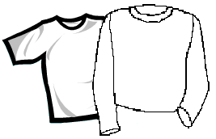  Old Trainers NO WELLIES, CROCS OR BOOTS  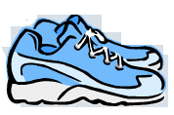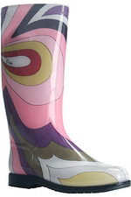  Long Trousers – No Jeans  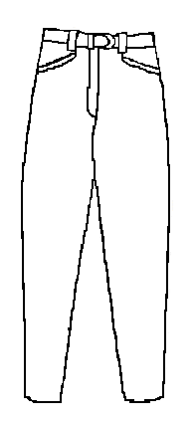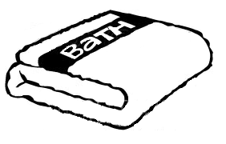  Bring Spare change of clothes and a towel | MOUNTAIN BIKING  You must wear a LONG SLEEVED top, LONG TROUSERS and CLOSED FOOTWEAR  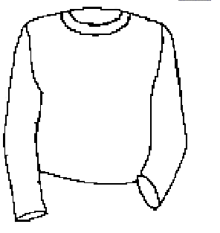  Bring a RUCKSACK and WATER  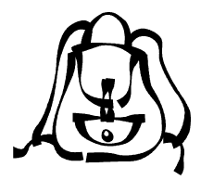   | HILLWALK AND EVENING WALK
 |  | Warm/Sunny Weather  You can wear shorts and T-Shirt as long as you have sun cream on. 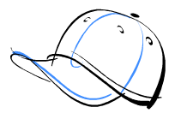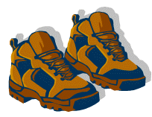 |  | Cool/Cold Weather  Must wear at least 2 WARM LAYERS  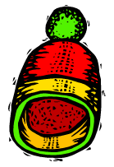
 |  | No matter what the weather WEAR SENSIBLE FOOTWEAR that supports your feet and take a WATERPROOF JACKET and TROUSERS with you
 | ARCHERY and RIFLES  You must wear a LONG SLEEVED top and CLOSED FOOTWEAR  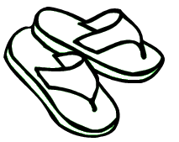 | BLIND TRAIL, OBSTACLE COURSE, LOW ROPES CLIMB and ABSEILING, | HIGH ROPES, ZIP WIRE, CRATE STACKING, HIGH ALL ABOARD & FENCING
 |  | Old clothes that are ok getting WET and DIRTY | TEAM GAMES, WIDE GAMES & MANOR OLYMPICS
Long trousers and long sleeved top (even if it is sunny)
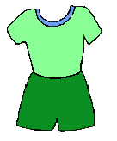

NO: SHORTS, T-SHIRTS, WELLIES, CROCS or SANDALS
Please make sure you are on time to all sessions, they can not start without you! If you have any questions about this ask an instructor Page 14

