Literacy | Numeracy | STEM | RERC
Spelling  Complete a variety of activities from the active spelling grid to practise your spelling words. | Mental Maths  Choose an activity from the active maths grid to practise your times tables and counting skills. | STEM-A-Story  Read the story or watch the video clip of the book ‘There is no dragon in this story’.  Create 3 houses for the Little Pigs out of different materials. Predict what you think would happen if the wolf came. Use a hair dryer to be the Big Bad Wolf and test your predictions. | Complete talking and written tasks for home activities *-* in your First Holy Communion workbook.  Continue to practise saying the prayers you have learned:  - Glory Be  - Our Father  - Hail Mary  - The Confiteor  - Apostles Creed  - Act of Sorrow
Reading  Read with someone at home every day. Think carefully about using expression when reading aloud. Choose a task from each column of the grid to complete for each book you finish. | Mangahigh  Use your numeracy skills to complete the challenges set for you on MangaHigh.  https://www.mangahigh.com/en/ | 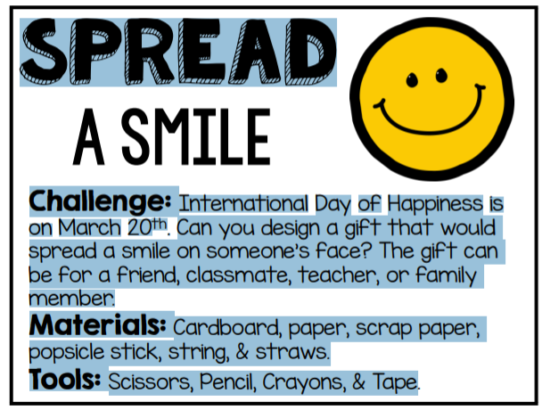  Design a gift that would make someone smile. The gift can be for a friend, teacher, classmate or family member. You can design this on paper or use materials you have at home to create it. It cannot be something that you can buy from a shop!
Writing  Pick an image from Pobble 365 and use the picture to help you create an imaginative story. Remember to include VCOP!  Keep a daily diary of all the things you do while you are off school. | My Math-o-poly  Create your own board game using your knowledge of addition, subtraction and multiplication. | Computer Science  Visit the Hour of Code website and choose one of the activities (Remember we have looked at Minecraft, Frozen, Star Wars and Dance Party)  Use your coding skills to complete as many of the levels as you can.
Weblinks  Pobble 365 - http://www.pobble365.com/  Complete tasks set on  https://www.educationcity.com/  https://www.linguascope.com/ | Weblinks  https://www.topmarks.co.uk/maths-games/hit-the-button  https://gregtangmath.com/games | Weblinks  https://hourofcode.com/uk/learn  https://www.youtube.com/watch?v=vAahy5HnEO4  GLOW - https://sts.platform.rmunify.com/account/signin/glow

