It’s Party Time!
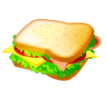
Party hats Sandwiches Crisps Hotdogs Pizzas
15p
15p
20p
20p
25p
each each each each each     
Coke Lemonade Ice creams Cakes Balloons
9p
10p
11p
8p
10p
each each each each each

You are having a party for 10 people. You have ONLY £10 to spend. Everybody must have a balloon, a party hat, a drink and AT LEAST 2 things to eat.
Work out what you can buy, how much money you will spend altogether and how much money you have left.

I can buy:

Altogether I spend

I have left.

