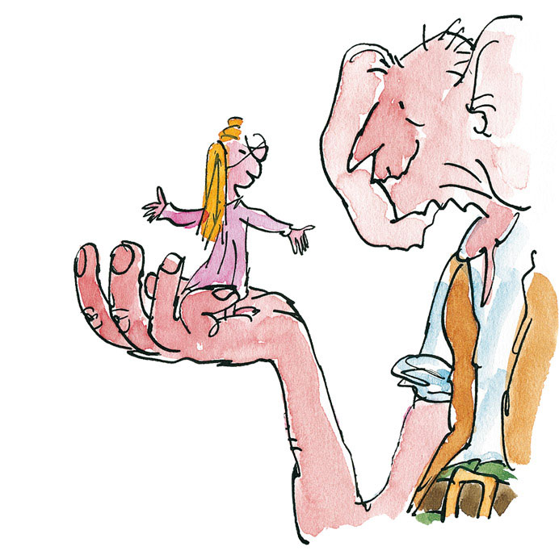
1. Sophie sat in the BFG’s pocket. She had an idea.

2. Sophie put the Snozzcumber in her mouth. She didn’t like it.

3. The BFG took down a jar from the shelf. He shook it.
The BFG Up-levelling Group Task:

Choose a pair of sentences below to up-level. You must try to use the following:

· V— Ambitious Words and WOW! Words
· C— Connectives
· O— Power Openers (ending in “ly”, “Ing” or use a connective as an Opener)
· P— Interesting and effective Punctuation

