Winter Scavenger Hunt
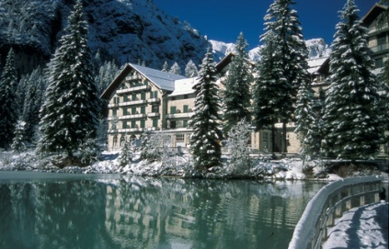
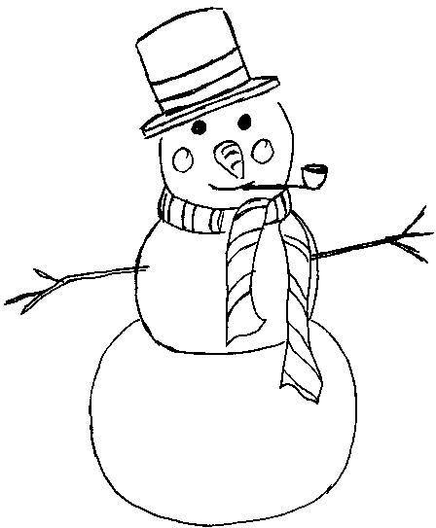
Can you find these things in the snow?
- Icicles
- Robin
- Bird feeder
- Snowman
- Animal tracks
- Frozen spider web

You can a take a picture to show the class or describe where you found them and what they looked like.

