St Patrick’s PRIMARY
SCHOOL & NURSERY

Anti-Bullying Policy

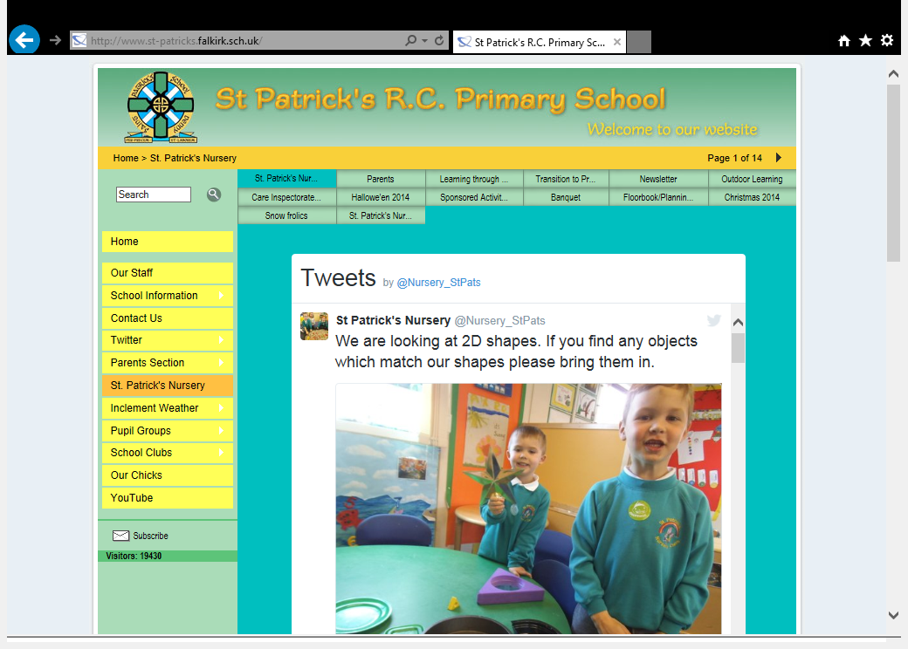

Respect and manners all around
Tell the truth, be safe and sound
and
A positive attitude will abound

St Patrick’s Anti-Bullying Policy

Statement

St. Patrick’s Primary School is a place where all are welcomed, loved, forgiven and encouraged to live the good life of the Gospel. We believe that all pupils, staff and parents/carers have the right to be protected from bullying and abusive behaviour and will not tolerate this kind of behaviour in our schools. We believe that all members of our school communities have the right to learn in an environment where they feel safe, respected and loved. We strive to keep the St Patrick’s Promise;
Respect and manners all around
Tell the truth, be safe and sound
and
A positive attitude will abound

Aims and Purposes

Our Anti-Bullying policy was developed and is reviewed and monitored through consultation with the whole school community and applies to all members of our community. This policy will be evaluated and reviewed regularly in consultation with all members of our school community

This policy aims to ensure that all those connected with the school are protected from bullying behaviour. This includes pupils, teachers, support staff, clerical staff, janitor, kitchen staff, families of our pupils and visitors to our school community. The ongoing and long-term aim of the policy is to reduce the number of pupils who experience bullying through increasing awareness of this behaviour, its causes and consequences amongst the pupils, staff, parents and carers who make up the school community, and to help pupils find and put into practice a series of solutions to the problem of bullying.

We aim to develop respectful, responsible and confident relationships as well as developing skills and resilience which will help to prevent and respond to bullying behaviour.

This policy also reflects the rights of the child as stated in the UN Convention of the Rights of the Child. In particular:
- Article 15 – Children have the right to meet together and to join groups and organisations, as long as it does not stop other people from enjoying their rights. In exercising their rights, children have the responsibility to respect the rights, freedoms and reputations of others.
- Article 19 – Children have the right to be protected from being hurt and mistreated, physically or mentally.
- Article 29 - Children’s education should develop each child’s personality, talents and abilities to the fullest. It should encourage children to respect others, human rights and their own and other cultures. It should also help them learn to live peacefully, protect the environment and respect other people.
- Article 31- Children have the right to relax and play, and to join in a wide range of cultural, artistic and other recreational activities.

Definition

The Scottish Government defines bullying behaviour as behaviour which leaves people feeling helpless, frightened, anxious, depressed or humiliated. Bullying behaviours may, but do not always, include:
- name calling, teasing, putting down or threatening
- ignoring, leaving out or spreading rumours
- hitting, tripping, kicking
- stealing and damaging belongings
- sending abusive text, email, instant messages or social media/network posts
- making people feel like they are being bullied or fearful of being bullied
- targeting someone because of who they are or are perceived to be (prejudice based bullying

As a school we recognise that this is not an exhaustive list. Our priority is the impact an incident or series of incidents has on a child rather than a bullying classification.

Prejudice Based Bullying

We have an obligation to address prejudice based bullying. This is where bullying behaviour focuses on part of someone’s identity and identified under the Equality Act 2010. Prejudice based bullying may address some of the following:

- Racist bullying – this is not just related to skin colour but also to ethnic or national origins, real or perceived.
- Sexist, gender based or homophobic bullying – directed at children who are perceived to be different for not conforming to strict gender norms.
- Disability related bullying – is used to describe the bullying behaviour towards someone based on their physical, mental or learning disabilities or perceived disability.
- Religion or belief bullying – is directed against individuals or groups because of their actual or perceived religious belief.
- Socio-economic bullying behaviour – is directed to individuals or groups affected by the poverty gap.

Prevention of Bullying Behaviour

We believe that if we work together as a community to encourage positive behaviour and promote Gospel values that underpin the Catholic ethos of our school, we will create a caring environment where every individual feels respected and safe. It is the responsibility of all to prevent bullying behaviour.

Responsibility of the School
- To promote, praise and reward positive behaviour
- To build and maintain a community in which everyone feels valued, respected and safe and where individual differences are appreciated, understood and accepted
- To promote a secure and happy, caring environment where kindness and helpfulness are expected and respected
- To provide a safe, supportive inclusive environment for all children including prevention of all forms of hurtful and bullying behaviours, as far as is reasonably practicable
- To build caring relationships and treat all members of our community with respect
- To encourage and support all staff to be responsible for addressing challenging behaviour
- To work with children to encourage them to take responsibility for the impact of their behaviour and to repair harm done
- To inform all members of our community of the school’s high expectations and how everyone can play a role in eradicating bullying

Responsibility of the Pupil
- To display positive behaviour towards all members of our community
- To act responsibly and treat others with respect; treat others as they would like to be treated
- To avoid any behaviour that could be defined as bullying behaviour through their actions, words and use of social media
- To participate fully in all activities that promote positive behaviour and raise awareness of what constitutes bullying behaviour
- To protect fellow members of our community by reporting bullying behaviour to a responsible adult
- To act as a role model and positive influence on peers

Responsibility of the Parent/Carer
- To support the school to build and maintain a community in which everyone feels valued, respected and safe and where individual differences are appreciated, understood, accepted and celebrated
- To work with young people to encourage them to take responsibility for the impact of their behaviour and to repair harm done
- To reinforce the school’s high expectations and stress how everyone can play a role in eradicating bullying behaviour
- To encourage their child to report any incidents of bullying behaviour to a member of school staff
- To discourage their child from becoming involved in any behaviour (through their actions, words and use of social media) that could be defined as bullying
- To report any incidents of cyber bullying to the appropriate authorities through the “CEOP Report Abuse” facility on most social media/networking sites or to the police (Child Exploitation and On-line Protection Agency)

Identifying Bullying

It is not always easy to identify when a child is being bullied. Respectme (Scotland’s Anti-Bullying Service) provide this list of various things to look out for:
- Obvious physical signs of being hurt
- Damage to personal belongings
- Unwillingness to go to school/absence from school
- Changes in behaviour, mood or attitude towards learning
- Child being more “clingy” or emotional than normal
- Changes in eating or sleeping patterns
- Signs of stress, anxiety, nervousness
- Pretending to be ill or becoming ill
- Bed wetting
- Self-harm
- Change in normal behaviour to fit in with others
- Unwilling to go out and play with friends
- Change in route taken to school
- Complaints about headaches, stomach aches or other pains
- Child becoming withdrawn

It should be noted that the above cannot solely be linked to bullying as these could also be related to other underlying medical or social issues.

Strategies and Procedures

In any situation where bullying has occurred respecting the rights of all the children involved is paramount. We aim to establish and maintain a culture of mutual respect and responsibility. We will address the needs of those bullied and the bully within a framework of respect, responsibility, resolution and support. Information will be shared (as appropriate) and we will work in partnership with those involved and their families to ensure a co-ordinated and cohesive response is established.

In St Patricks:
- Bullying will be taken seriously and bullying behaviour will be challenged.
- If you are experiencing bullying behaviour or witness bullying behaviour you must report it immediately. You will be taken seriously and treated with respect at all times.
- We will work with the child who is being bullied to help them feel safe and find solutions to the bullying behaviour. Regular up-dates and check-ins will be carried out.
- We will work with the child or children who are displaying bullying behaviour to allow them to reflect on their actions and the impact of their actions on others in order to support them in changing their behaviour.
- We will work with both parties to ensure that relationships can be reconciled through restorative conversations (when applicable).
- Staff will inform the parents/carers of any person who is being bullied to support and encourage that person in finding solutions to the bullying behaviour.
- Staff will inform the parents/carers of any child who is displaying bullying behaviour to support and encourage that child to stop bullying behaviour.
- We will support parents with incidents of cyberbullying at home by facilitating discussions, where appropriate, to end this behaviour and help restore relationships with all children involved.
- We will continuously raise awareness of bullying behaviour and how this can be prevented and responded to. This will be through developing awareness and understanding of respectful relationships with all members of our school community and ensuring a consistency in approaches.
- Incidents of bullying behaviour will be recorded using the Falkirk Council management system.
- There may be a situation where we feel it is appropriate to access specialist support from outside agencies to help pupils deal with the impact of bullying behaviour or support to develop better relationships and improve their interactions with others. In some cases, an issue of bullying behaviour in school could relate to more serious concerns outside school and could result in a meeting being set up in school to include other agencies such as Educational Psychologist, Social Work, Health or Police.

Practical Approaches
Throughout the school year children will be given opportunities to develop their understanding and awareness of bullying behaviour as well as developing resilience strategies in order to prevent and respond to bullying behaviour. This will be a particular focus during term one with a class focus on SHANARRI (Safe, Healthy, Achieving, Nurtured, Active, Respected, Responsible and Included) and during anti-bullying week. We will also aim to:
- Develop awareness of children’s rights
- Develop an inclusive and positive ethos and a climate of respect. Bullying and discrimination is unacceptable
- Provide personal support for those involved
- Provide support to enable parents to support their children
- Develop, as appropriate, a system for buddies to support children during unstructured times such as playtimes and lunchtimes
- Share information and helpful strategies the children can use to develop resilience and prevent and respond to bullying behaviour in a positive manner. This may include strategies, websites, leaflets etc

In St. Patrick’s we encourage all children to live according to Gospel Values and ensure these values permeate all that we do. Bullying behaviour will not be tolerated in our school and will be challenged to ensure that all children can learn and thrive in an environment in which they feel safe, loved and respected.

This policy is based on a policy devised by St Mungo’s Cluster and adapted for St Patrick’s in line with; school needs, St Modan’s Anti-Bullying Policy and Falkirk Council Anti-Bullying Policy

